
Teachers’ guide and students’ material
A card game with
The Gapminder
World Map

About this document
By Mattias Lindgren, the Gapminder Foundation, based on an idea by Paula Cooper. Version: 02/09/2010
This guide is available at: www.gapminder.org/downloads/card-game
Cover photo by: Meeralee http://bit.ly/b9GLwv

More teaching materials available at www.gapminder.org/for-teachers/

License
You are free to use and re-distribute this material
for non-commercial purposes under a creative
commons licence. We ask you to credit as the source: www.gapminder.org

More teaching materials available at www.gapminder.org/for-teachers/

About this lesson
Level: secondary school. Subjects: history, geography & social studies. What you need: only this document.
Outline: The students will try to arrange “country cards” in an order that illustrates the gaps in the world today. They then compare their arrangement with the “Gapminder World Map” graph.

Key messages of the exercise

The exercise can help the students to think about the gaps in the world today and challenge preconceived ideas about how the contemporary world looks. The exercise can also be used to stimulate an interest in using statistics to understand the world.

About the data in the graph

The data in the Gapminder World graph has been compiled from a variety of sources. Data from high-income countries is mainly from registers, whereas surveys are a common source in low and middle-income countries. Such surveys are based on interviews with a representative sample of the population. Information about sources can be found at www.gapminder.org/worldmap.
The uncertainty of the data varies, but there is a consensus regarding the general pattern. The graph uses what is known as a log-scale, a scale which expands at low values and compresses at high values. The log scale gives a more correct picture when we look at incomes. For example, $100 extra per year makes a huge difference for a person earning $400. The same $100 addition might not even be noticed by someone earning a $100,000.
Some middle-income countries, such as South Africa and Botswana, have a remarkably low life expectancy compared to other countries with the same incomes. The main reason for this is the AIDS epidemic, which has hit these countries particularly hard. HIV and AIDS affect rich and poor alike. The relative high incomes in these countries have been used to give treatment to some of those infected, but they have not yet been able to stop the transmission of the disease.

How to do the exercise

1. Divide the class into groups with 3-5 students in each group.

2. Prepare the material. The following material will be used:
- “The country cards” that are available for printing on page 3. Distribute one set of cards to each group.
- An ordinary world map, if you have one. This is not essential, but it could be good if the students can get a better sense of where in the world the countries on the cards are.
- The graph “Gapminder World Map” that is available for printing on page 4. Print one graph for each group, but don’t distribute them yet.

3. Ask the students to arrange the country cards according to the development level of the countries. You do not have to be more specific than this, let the students come up with their own ways of grouping the countries (e.g. they might sort them into two groups, several groups or arrange them into one line).

4. Ask them to explain how they arranged the cards. Does their way of sorting the countries reflect what they think the incomes of the countries are? Health? Development, in a more vague sense?

5. Distribute the “Gapminder World Map” graph to the groups. Explain the graph, i.e. that each bubble is a country, the size of the bubble is the population, the colour the continent, the Y-axis is the life expectancy (i.e. health) and the X-axis is income per person. Explain quickly what the two indicators mean.

6. Ask them to find and mark the countries on the graph.

7. Discuss whether there were any surprising results. Discuss whether the graph could be used to divide the countries of the world into different categories.
China  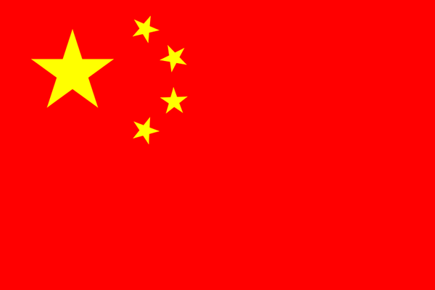  Capital: Beijing  Location: Eastern Asia | Bangladesh    Capital: Dhaka  Location: Southern Asia | South Africa  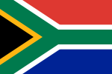  Capital: Pretoria  Location: Southern Africa | United States    Capital: Washington DC  Location: North America
South Korea    Capital: Seoul  Location: Eastern Asia | Mexico    Capital: Mexico City  Location: Latin America | Brazil  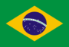  Capital: Brasilia  Location: Latin America | Ukraine  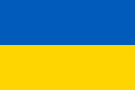  Capital: Kiev  Location: Eastern Europe
India    Capital: New Delhi  Location: Southern Asia | Dem. Rep. of the Congo    Capital: Kinshasa  Location: Central Africa | Singapore  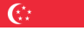  Capital: Singapore  Location: South East Asia | Botswana  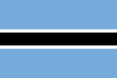  Capital: Gaborone  Location: Southern Africa
Ethiopia    Capital: Addis Ababa  Location: Eastern Africa | Nigeria    Capital: Abuja  Location: Western Africa | Japan    Capital: Tokyo  Location: Eastern Asia | Russia  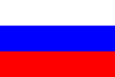  Capital: Moscow  Location: Eastern Europe / Northern Asia

